YEAR 7 SCIENCE
BIOLOGICAL SCIENCES
INVESTIGATION - DECOMPOSERS

Aim: To determine the conditions required for a decomposer such as fungi to work.

Equipment: • Slice of dry bread.
• Two clean petri dishes
• Special sealing tape.

Hypothesis: (What do you think you will observe?)

Method:
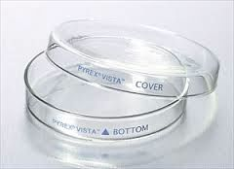
• Set up the following petri dishes.

Dish 1 - place a piece of bread, moisten with a few drops of water, expose to the air for 20 minutes.
Cover and seal.

Dish 2 - place a piece of bread, expose to the air for
20 minutes. Cover and seal.

• Label the bottom of each petri dish with the following.

Name:

Date:

Bread: Moist or dry.

• Take a photo of the dishes - this is the start of a photo record of the decomposition.

• Place them in a dark cupboard and observe them over a period of 5 - 7 days. Record your observations by a photo and written description.

Observations: (For each day of observation, put a photo and describe what it shows.)

Date: Day Number: 0 (when you set up the investigation)

Date: Day Number:

Date: Day Number:

Date: Day Number:

Discussion:

Conclusion:

